CSS  
  
  
**Q1:-**  What are the benefits of using CSS?  
 **Ans. :-** Cascading Style Sheets (CSS) offer several benefits in web development by providing a way to control the layout, presentation, and styling of HTML documents. Here are some key benefits of using CSS:  
  
  
**1.Separation of Content and Presentation:**

* + CSS allows for the separation of content (HTML structure) and presentation (styling). This separation makes it easier to maintain and update a website since changes to the style can be made without altering the underlying HTML structure.

1. **Consistent Styling:**
   * With CSS, you can define styles centrally and apply them consistently across multiple pages of a website. This ensures a uniform look and feel, providing a better user experience.
2. **Flexibility and Control:**
   * CSS offers fine-grained control over the presentation of elements on a web page. You can control the layout, colors, fonts, spacing, and other visual aspects to achieve the desired design.
3. **Responsive Design:**
   * CSS supports responsive web design, allowing developers to create layouts that adapt to different screen sizes and devices. Media queries in CSS enable the creation of designs suitable for desktops, tablets, and mobile devices.
4. **Ease of Maintenance:**
   * Since styles are defined in a separate CSS file or within the HTML document, making changes to the visual appearance of a website is more efficient. This makes maintenance and updates faster and less error-prone.
5. **Improved Page Load Times:**
   * External CSS files can be cached by browsers, which can lead to faster page load times for subsequent visits. This is because the browser can reuse the cached style sheets instead of downloading them again.
6. **Accessibility:**
   * CSS allows for the creation of accessible designs, making it easier for users with disabilities to navigate and understand the content. Properly structured HTML combined with CSS can enhance the accessibility of web pages.
7. **Platform Independence:**
   * CSS is supported by all major web browsers and is platform-independent. This ensures a consistent appearance of web pages across different browsers and operating systems.
8. **Animations and Transitions:**
   * CSS supports animations and transitions, allowing developers to create visually appealing effects without relying on JavaScript. This can enhance the user experience and engagement on a website.
9. **Print Styling:**
   * CSS provides the ability to create specific styles for printed documents. This ensures that when a user prints a web page, the printed version is formatted and styled appropriately for paper.
10. **Q2:-** What are the disadvantages of CSS?  
      
    ANS:- While CSS has many advantages, there are also some challenges and disadvantages associated with its use in web development. Here are some of the common drawbacks:  
      
    **1. Cross-browser Compatibility:**
    * Ensuring consistent rendering across different web browsers can be challenging. Browsers may interpret CSS rules differently, leading to variations in the appearance of a website. Developers often need to write additional code or use vendor prefixes to address browser-specific issues.
11. **Learning Curve:**
    * For beginners, CSS can have a steep learning curve, especially when dealing with more advanced features and responsive design. Understanding the box model, positioning, and layout techniques may take time and practice.
12. **Limited Layout Control:**
    * Achieving complex layouts, such as equal-height columns, can be challenging with CSS alone. Some layout requirements may necessitate the use of additional techniques, such as flexbox or grid, which may not be supported in older browsers.
13. **Global Scope of Styles:**
    * CSS operates globally, meaning that styles defined for one element can affect others on the page. This can lead to unintentional styling conflicts and make it harder to isolate and troubleshoot issues.
14. **Performance Impact:**
    * Large and complex style sheets can impact the performance of a website, especially on slower network connections. Minimizing and optimizing CSS files can help mitigate this issue.
15. **Lack of Variables and Constants:**
    * Unlike some programming languages, CSS traditionally lacked native support for variables and constants. However, CSS preprocessors like Sass and Less have introduced variable support to address this limitation.
16. **Limited Expressiveness:**
    * CSS is primarily a styling language and lacks the expressive power of programming languages. While newer features like CSS Custom Properties and Calc provide more functionality, CSS is not designed for complex logic and calculations.
17. **Browser Support for New Features:**
    * Implementing the latest CSS features may be limited by the support of those features in different browsers. New CSS features may not be supported uniformly across all browsers, requiring developers to use fallbacks or alternative approaches.
18. **Maintenance Challenges:**
    * Large and complex stylesheets can become challenging to maintain over time. Without proper organization and documentation, it may be difficult to understand and update the styles, leading to increased maintenance efforts.
19. **Print Limitations:**
    * While CSS provides print styling capabilities, achieving precise control over the printed layout can be challenging. Print styles may not always translate perfectly from the screen to paper.

### Q3:- What is the difference between CSS2 and CSS3? ANS:- CSS (Cascading Style Sheets) is a style sheet language used for describing the presentation of a document written in HTML or XML. CSS evolves over time, and different versions introduce new features and improvements. The main difference between CSS2 and CSS3 lies in the set of features and capabilities each version offers. Here's a brief overview: CSS2 (Cascading Style Sheets Level 2):

1. **Release Date:**
   * CSS2 was published as a W3C Recommendation in May 1998.
2. **Modules:**
   * CSS2 introduced a modular approach, dividing the specification into several modules such as Box Model, Visual Formatting Model, and Generated Content. Each module addressed specific aspects of styling and layout.
3. **Selectors:**
   * CSS2 selectors included basic selectors like type selectors, class selectors, ID selectors, descendant selectors, etc. However, it did not have as many advanced selectors as later versions.
4. **Positioning:**
   * CSS2 introduced positioning properties such as **position**, **top**, **right**, **bottom**, and **left**. It laid the foundation for basic layout control but lacked features like flexbox and grid.
5. **Media Types:**
   * CSS2 allowed the definition of stylesheets for different media types, such as screen, print, and handheld devices.
6. **Visual Effects:**
   * CSS2 included properties for basic visual effects like **text-decoration**, **color**, and **background**.

**CSS3 (Cascading Style Sheets Level 3):**

1. **Release Date:**
   * CSS3 is not a single monolithic release but a collection of modules that have been developed and released independently. The development of CSS3 began around the mid-2000s, and different modules reached Recommendation status at various times.
2. **Modules:**
   * CSS3 is divided into numerous modules, each focusing on specific features. Some notable modules include Selectors Level 3, Color, Text, Box Model, Flexbox, Grid Layout, Transitions, Animations, and more.
3. **Selectors:**
   * CSS3 introduced more advanced selectors, including attribute selectors, child selectors, adjacent sibling selectors, and the powerful **:nth-child** pseudo-class.
4. **Media Queries:**
   * CSS3 introduced media queries, allowing styles to be applied based on characteristics of the device or viewport, enhancing support for responsive web design.
5. **Box Model Enhancements:**
   * CSS3 introduced enhancements to the box model, including the **box-sizing** property and the ability to create rounded corners and shadows without the need for images.
6. **Flexible Box Layout (Flexbox):**
   * CSS3 introduced the Flexbox layout model, providing a more efficient way to design complex layouts and distribute space among items in a container.
7. **Grid Layout:**
   * CSS3 introduced the Grid Layout module, allowing developers to create two-dimensional layouts with rows and columns, providing more control over the placement and alignment of elements.
8. **Transitions and Animations:**
   * CSS3 introduced properties for transitions (**transition**) and animations (**@keyframes**), enabling smoother and more dynamic changes in the presentation of elements.
9. **Custom Properties (CSS Variables):**
   * CSS3 introduced custom properties, allowing developers to define reusable values in stylesheets, improving maintainability.
10. **Multi-column Layout:**
    * CSS3 introduced the ability to create multi-column layouts with the **column-count** and related properties.

**Q4:-** Name a few CSS style components  
ANS:-1. **Color:**

* The **color** property is used to set the text color of an element. It can accept color names, hexadecimal codes, RGB values, or HSL values.  
    
  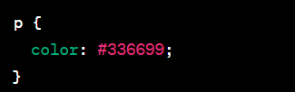

**2. Font:**

* + Font-related properties like **font-family**, **font-size**, **font-weight**, and **font-style** control the typography of text within an element.

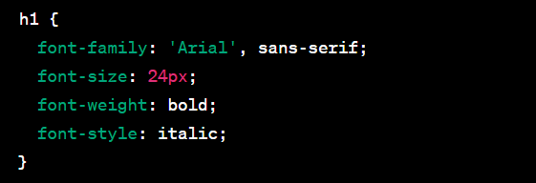  
  
 **3 Background:**

* The **background** property is used to set background-related styles, including **background-color**, **background-image**, **background-position**, and **background-repeat**.

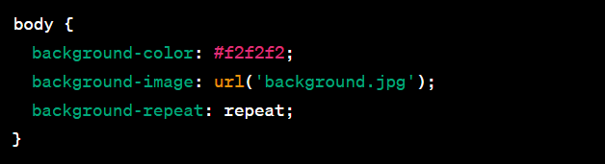  
  
  
  
  
  
  
  
  
  
  
  
  
4. **Box Model:**The box model components include properties like **width**, **height**, **margin**, **padding**, and **border**,which control the size and spacing of elemets.  
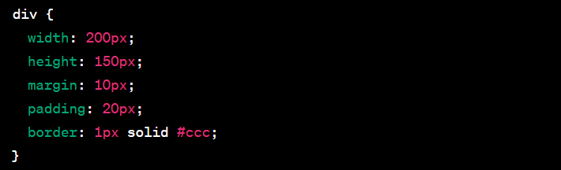

**Q5:-** What do you understand by CSS opacity?  
ANS:- CSS **opacity** is a property that controls the transparency of an element, affecting the visibility of both the element and its content. The **opacity** property accepts values between 0 and 1, where 0 indicates complete transparency (invisible), and 1 indicates full opacity (completely visible). Values between 0 and 1 represent varying levels of translucency.

**Q6:-** How can the background color of an element be changed?  
ANS:- The background color of an HTML element can be changed using the CSS **background-color** property. This property sets the background color of an element, and you can specify the color using various methods, including color names, hexadecimal codes, RGB values, or HSL values. Here are a few examples:  
  
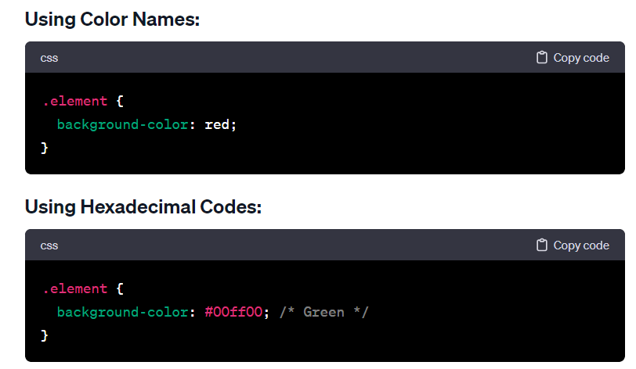  
  
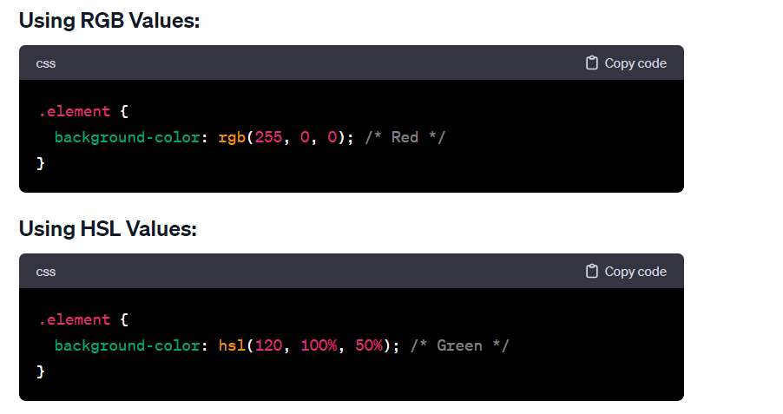

**Q7:-** • How can image repetition of the backup be controlled?  
ANS:- If you're referring to controlling the repetition of a background image in CSS, you can use the **background-repeat** property. This property allows you to specify whether and how a background image should be repeated both horizontally and vertically. The **background-repeat** property accepts the following values:

* **repeat**: The default value. The background image is repeated both horizontally and vertically.
* **repeat-x**: The background image is repeated horizontally.
* **repeat-y**: The background image is repeated vertically.
* **no-repeat**: The background image is not repeated.

**Q8:-** What is the use of the background-position property? **ANS:-** The **background-position** property in CSS is used to specify the starting position of a background image within its containing element. It determines where the top-left corner of the background image should be placed, and it accepts various values to control its positioning. The property can take one or two values, representing the horizontal and vertical positions, respectively.

* 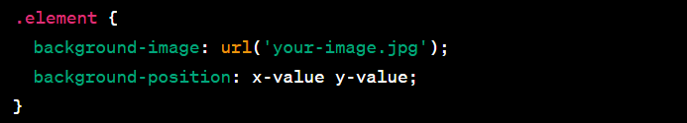  
    
    
  **x-value**: Can be a length value (such as pixels or percentages) or a keyword (e.g., **left**, **center**, **right**).
* **y-value**: Similar to **x-value**, it can be a length value, a percentage, or a keyword (**top**, **center**, **bottom**).

**Q9:-** Which property controls the image scroll in the background?  
ANS:- The property that controls the background image scroll in web development is usually the **background-attachment** property in CSS. The **background-attachment** property determines whether a background image scrolls with the rest of the page or remains fixed in place.

There are three possible values for the **background-attachment** property:

1. **scroll**: This is the default value. The background image will scroll along with the content of the web page.  
     
   2. **fixed**: The background image will remain fixed in place while the content of the web page scrolls. This creates a parallax effect.  
     
   3. **local**: The background image will scroll with the element's contents. This is not supported in all browsers.

**Q10:-** Why should background and color be used as separate properties?  
ANS:- In CSS, the **background** property is a shorthand property that combines several individual background-related properties into one. These properties include **background-color**, **background-image**, **background-repeat**, **background-position**, **background-size**, **background-attachment**, and **background-origin**. While it's convenient to use the **background** shorthand for simplicity and brevity, there are situations where using **background-color** and **background-image** as separate properties can be beneficial. Here are some reasons:

1. **Clarity and Readability:** Separating **background-color** and **background-image** makes the code more readable and easier to understand, especially for those who may be reviewing or maintaining the code. It provides a clear distinction between the color and image aspects of the background.  
     
   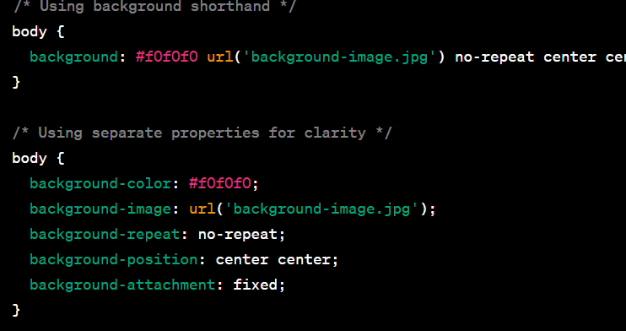  
     
   **2. Ease of Modification:** If you want to change only the color or only the image, using separate properties allows for easy modification without affecting the other aspects of the background.  
     
   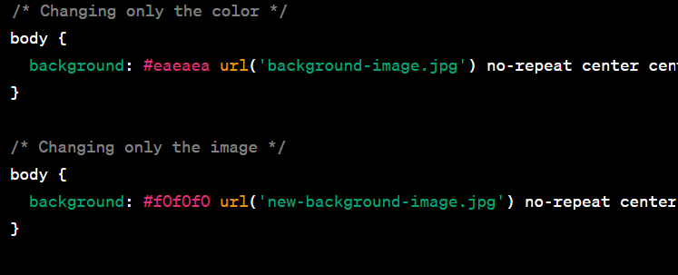  
     
   **3. Fallbacks and Graceful Degradation:** When dealing with older browsers or situations where the image may not load, having a separate **background-color** provides a fallback. This ensures that even if the image fails to load, there is still a background color visible.
2. Q11:- • How to center block elements using CSS1?  
   ANS:- CSS1 (Cascading Style Sheets, Level 1) is the initial version of the CSS specification, and it was first introduced in 1996. CSS1 has limited capabilities compared to the later versions of CSS. Centering block elements, especially vertically, can be a bit challenging with CSS1 alone. However, here's a basic example of horizontally centering a block-level element using CSS1:  
     
   1. The **body** element has **text-align: center;**. This will horizontally center all inline and inline-block elements within the **body**.
3. The block element with the class **.center-block** has **display: inline-block;**. This makes the block element behave like an inline-block element, allowing it to be horizontally centered within the **body**.

Q12:- How to maintain the CSS specifications?  
ANS:- Maintaining CSS specifications involves staying informed about updates, following best practices, and adapting to changes in the web development landscape. Here are some general guidelines to help you maintain CSS specifications effectively:

1. **Stay Informed:**
   * Regularly check official sources such as the World Wide Web Consortium (W3C) website for updates on CSS specifications. The W3C is the organization responsible for developing web standards.
   * Follow blogs, forums, and social media accounts of web development experts and organizations to stay informed about best practices and emerging trends.
2. **Use Official Documentation:**
   * Refer to the official CSS documentation provided by the W3C for accurate and up-to-date information. The CSS specifications are well-documented, and the official documentation is the most reliable source.
3. **Understand Browser Compatibility:**
   * Be aware of browser compatibility issues and use tools like caniuse.com to check the compatibility of CSS properties across different browsers. Consider using vendor prefixes when necessary for experimental or browser-specific features.
4. **Follow Best Practices:**
   * Adhere to best practices and coding standards to write maintainable and scalable CSS code.
   * Consider using a preprocessor like Sass or LESS to enhance your CSS workflow and maintainability.
5. **Update Tools and Libraries:**
   * Keep your development tools, frameworks, and libraries up to date. This includes your text editor, build tools, and any CSS frameworks you may be using.
6. **Test and Debug:**
   * Regularly test your CSS code across different browsers and devices to identify and address any compatibility issues.
   * Use browser developer tools to debug and inspect your CSS code.
7. **Adopt Responsive Design:**
   * Embrace responsive design principles to ensure your layouts work well on various screen sizes and devices. CSS specifications often evolve to support responsive design practices.
8. **Consider Performance:**
   * Optimize your CSS code for performance by minimizing file sizes, reducing the number of HTTP requests, and using techniques like lazy loading for non-critical styles.
9. **Attend Conferences and Meetups:**
   * Attend web development conferences, meetups, and workshops to learn from industry experts, network with peers, and stay updated on the latest trends and advancements in CSS.
10. **Community Involvement:**
    * Engage with the web development community through forums, discussion groups, and social media. Participate in discussions, ask questions, and share your knowledge with others.

Q13:- What are the ways to integrate CSS as a web page?  
ANS:- There are several ways to integrate CSS into a web page. The choice of method depends on your specific needs and the complexity of your project. Here are the common ways to integrate CSS into a web page:

1. **Inline Styles:**
   * Inline styles involve placing the CSS directly within the HTML document using the **style** attribute. This method is suitable for applying styles to a specific element.
2. **Internal Styles (Embedded Styles):**

* Internal styles are defined within the HTML document using the **<style>** element in the document's . **<head>** section. This method allows you to apply styles to multiple elements within the same HTML document.

1. **External Styles (Linked Stylesheets):**

* External styles involve linking an external CSS file to the HTML document using the **<link>** element in the **<head>** section. This method is recommended for larger projects as it allows for better organization and reuse of styles across multiple pages.

Q14:- What is embedded style sheets?   
ANS:- Embedded styles, also known as internal styles or embedded style sheets, refer to the practice of including CSS styles directly within the HTML document using the **<style>** element. This method allows you to define styles that are specific to a particular HTML document and are contained within the document itself.

* Q15:- What are the external style sheets?  
  ANS:- External stylesheets refer to separate CSS files that are linked to HTML documents using the **<link>** element. This approach allows you to define styles in a separate file, promoting better organization, reusability, and separation of concerns in your web development projects.  
    
  The CSS rules are defined in a separate file named **styles.css**.
* The HTML document includes a **<link>** element in the **<head>** section, specifying the **href** attribute with the path to the external CSS file (**styles.css**).

Advantages of External Stylesheets:

1. **Modularity and Reusability:** External stylesheets promote modularity by allowing you to reuse the same stylesheet across multiple HTML pages. This is particularly useful for maintaining a consistent look and feel across a website.
2. **Separation of Concerns:** External stylesheets contribute to the separation of concerns in web development. HTML focuses on content structure, while CSS handles the presentation and styling. This separation makes the codebase easier to maintain and understand.
3. **Easier Maintenance:** Changes to the styling can be made in a single external stylesheet, and those changes automatically apply to all linked HTML documents. This simplifies maintenance and updates.
4. **Caching and Performance:** External stylesheets are often cached by browsers, improving performance for returning visitors. Subsequent page loads can benefit from the cached stylesheet without re-downloading it.

Q16:- What are the advantages and disadvantages of using external style sheets?  
ANS:- Using external stylesheets in web development has several advantages and a few potential disadvantages. Here's an overview of both:

**Advantages:**

1. **Modularity and Reusability:**
   * **Advantage:** External stylesheets promote modularity by allowing you to reuse the same stylesheet across multiple HTML pages. This is beneficial for maintaining a consistent look and feel throughout a website.
2. **Separation of Concerns:**
   * **Advantage:** External stylesheets contribute to the separation of concerns in web development. HTML focuses on content structure, while CSS handles the presentation and styling. This separation makes the codebase easier to maintain and understand.
3. **Easier Maintenance:**
   * **Advantage:** Changes to the styling can be made in a single external stylesheet, and those changes automatically apply to all linked HTML documents. This simplifies maintenance and updates.
4. **Caching and Performance:**
   * **Advantage:** External stylesheets are often cached by browsers, improving performance for returning visitors. Subsequent page loads can benefit from the cached stylesheet without re-downloading it.
5. **Consistent Styling:**
   * **Advantage:** External stylesheets ensure a consistent styling approach across all pages that link to the same stylesheet. This is crucial for branding and user experience.
6. **Ease of Collaboration:**
   * **Advantage:** External stylesheets make it easier for multiple developers or teams to collaborate on a project. The styling can be maintained separately from the HTML, facilitating teamwork.

**Disadvantages:**

1. **Additional HTTP Request:**
   * **Disadvantage:** Each external stylesheet results in an additional HTTP request. While modern browsers are optimized for handling multiple requests, minimizing the number of requests can still be a consideration for performance.
2. **Dependency on External Resources:**
   * **Disadvantage:** The rendering of the page depends on the availability and loading of the external stylesheet. If the stylesheet fails to load or there is a network issue, it can affect the visual presentation of the page.
3. **Not Suitable for Offline Use:**
   * **Disadvantage:** If a user accesses a page while offline or in situations with limited connectivity, external stylesheets may not be available, leading to unstyled content.
4. **Potential for Overreliance on Global Styles:**
   * **Disadvantage:** When using a global stylesheet for an entire website, there's a risk of overreliance on global styles that may not be suitable for specific pages or components. This could limit the flexibility of individual page styling.

Q17:- What is the meaning of the CSS selector?  
ANS:- In CSS (Cascading Style Sheets), a selector is a pattern or expression that specifies which elements in an HTML document should be styled by the associated rules. Selectors target HTML elements based on their type, attributes, relationships to other elements, or other characteristics. The rules defined for a selector dictate how the selected elements should be styled.  
  
**Element Selector:**

* Selects elements based on their HTML tag name. For example, **p** selects all **<p>** (paragraph) elements.

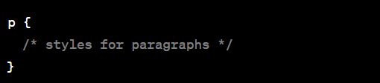  
  
**Class Selector:**

* Selects elements with a specific class attribute. Class selectors are preceded by a dot (**.**) and are written as **.classname**. For example, **.highlight** selects all elements with **class="highlight"**.

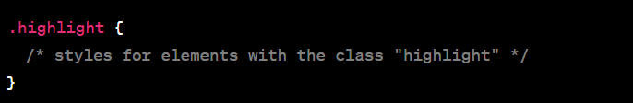  
  
**ID Selector:**

* Selects a single element with a specific ID attribute. ID selectors are preceded by a hash (**#**) and are written as **#idname**. For example, **#header** selects the element with **id="header"**.

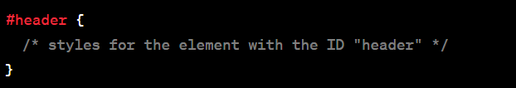  
  
**Attribute Selector:**

* Selects elements based on their attributes. Attribute selectors are written in square brackets. For example, **[type="text"]** selects all elements with **type="text"**.

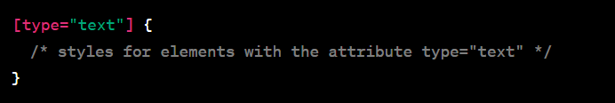  
  
**Combination of Selectors:**

* Selectors can be combined to target more specific elements. For example, **h2.title** selects all **<h2>** elements with the class "title".

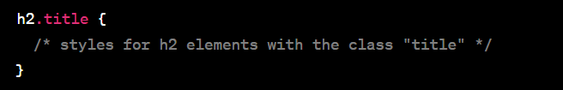  
  
**Descendant Selector:**

* Selects an element that is a descendant of another element. For example, **ul li** selects all **<li>** elements that are descendants of a **<ul>** element.

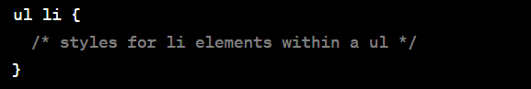

Q18:- What are the media types allowed by CSS?  
ANS:- CSS (Cascading Style Sheets) allows you to apply styles based on different media types, enabling you to create styles tailored for specific devices or environments. The **@media** rule is used to define different styles for different media types. Here are some common media types allowed by CSS:  
  
**all:**

* This is the default media type. Styles defined for **all** apply to all devices.

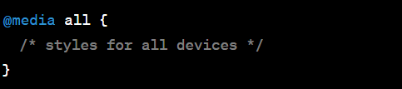  
  
**print:**

* Styles defined for the **print** media type apply when the document is printed.

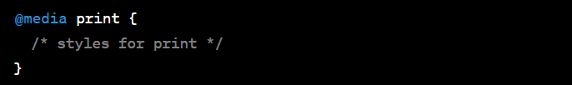  
  
**screen:**

* Styles defined for the **screen** media type apply to devices with screens, such as computer monitors.

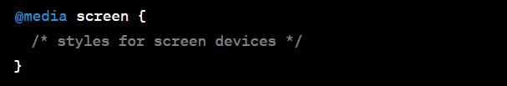  
  
**speech:**

* Styles defined for the **speech** media type apply to speech synthesizers or screen readers.

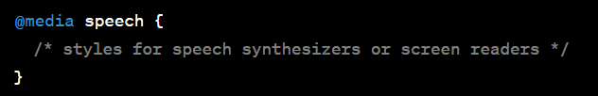  
  
**only:**

* The **only** keyword is used to hide styles from older browsers that do not support media queries.

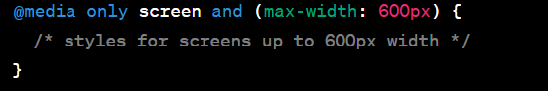  
  
**not:**

* The **not** keyword is used to apply styles if a certain condition is not true.

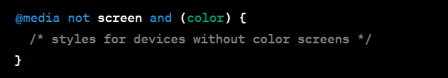  
  
**and:**

* The **and** keyword is used to combine multiple conditions within a media query.

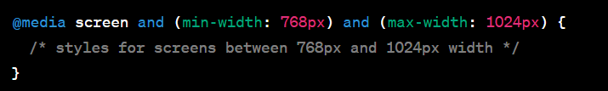

Q19:- What is the rule set?  
ANS:- In CSS (Cascading Style Sheets), a rule set consists of one or more style rules that define how a specific HTML element or group of elements should be styled. A rule set is composed of two main components: a selector and a declaration block.  
  
**Selector:**

* The selector is used to target HTML elements to which the styles will be applied. It can be an HTML tag, a class, an ID, or a combination of these. The selector defines the scope of the styling.

**Declaration Block:**

* The declaration block is enclosed within curly braces **{}** and contains one or more property-value pairs separated by semicolons. Each property-value pair defines a styling rule for the selected element(s).

